[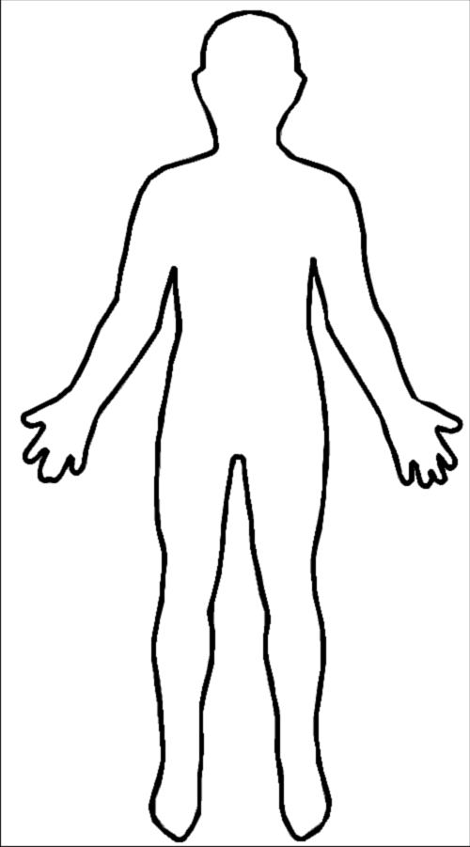](http://www.google.co.uk/url?sa=i&rct=j&q=&esrc=s&frm=1&source=images&cd=&cad=rja&docid=1oJBFmLHBtfyhM&tbnid=QddO1A5jMggyaM:&ved=0CAUQjRw&url=http://en.wikipedia.org/wiki/File:Outline-body.png&ei=EJGxUfG5DMLI0AXI4YGYAw&bvm=bv.47534661,d.ZG4&psig=AFQjCNH73qWJUWbuw8CZNpI3UcHSIdZwPg&ust=1370677901263655)

**Psychologically**: *What is the writer saying overall about this character’s mental state? How have they been impacted by the events and ideas in the text? What is the writer saying overall about this character? How is the reader supposed to react to the character’s experience?*

**Emotionally:** *What does the character say about their feelings? How does their language and tone show what they think and feel?*

**Physically**: *How does the character act, move, speak? What do they DO to show you how they are feeling?*

**Physically**: *How does the character act, move, speak? What do they DO to show you how they are feeling?*

**Emotionally:** *What does the character say about their feelings? How does their language and tone show what they think and feel?*

**Psychologically**: *What is the writer saying overall about this character’s mental state? How have they been impacted by the events and ideas in the text? What is the writer saying overall about this character? How is the reader supposed to react to the character’s experience?*