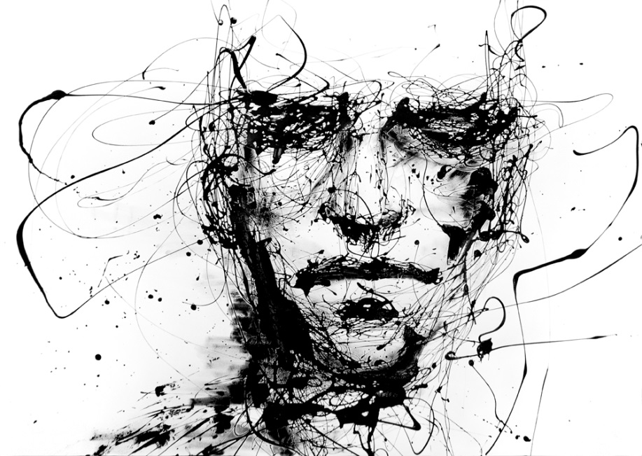

**How is the context relevant?**

**How is the context relevant?**

**How does the reader FEEL?**

**How does the STRUCTURE add to the meaning?**

**How does the STRUCTURE add to the meaning?**

**How does the reader FEEL?**

**What kind of language/imagery is being used?**

**What kind of language/imagery is being used?**

**How does the speaker FEEL?**

**How does the speaker FEEL?**

**The Man He Killed**

**A Poison Tree**